Name: Nevenka Ožanić
E-mail: nozanic@uniri.hr
Institution: University of Rijeka, Faculty of Civil Engineering
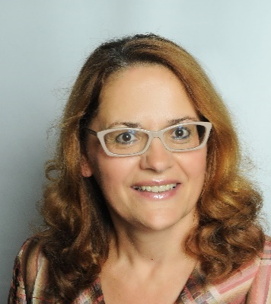 | Nevenka Ožanić, full time professor at the University of Rijeka, Faculty of Civil Engineering - UNIRIFCE (Croatia) was born in Kamenica on 20th April 1963. She graduated at the UNIRIFCE in 1986, obtained MSc CEng at the University of Zagreb in 1993 and in 1996 obtained PhD CEng at the University of Split. Since March 1986 she has been working in Croatian waters. From 2001 she is working at the UNIRIFCE as the head of the Department of Hydrotechnics and Geotechnics. Since 2003 she has been Vice dean for business relationships, and from 2004 to 2009 as the Dean of UNIRIFCE. From 2009 until 2017, she was Vice-Rector for Science and Development, University of Rijeka. Fields of interest: Hydrology, Hydraulic, and Water resources management. Teacher of more than 10 different academic courses, mentored 150 students on their graduate and master thesis, and 7 PhD students. A detailed list of published papers: https://bib.irb.hr/lista-radova?autor=213993
References (max. 5 relevant references)
1. Volf, Goran; Žic, Elvis; Ožanić, Nevenka. Prediction of groundwater level fluctuations on grohovo landslide using rule based regression. // Engineering review (Technical Faculty University of Rijeka), 38 (2018), 1; 51-61;
2. Krvavica, Nino; Kožar, Ivica; Ožanić, Nevenka. The relevance of turbulent mixing in estuarine numerical models for two-layer shallow water flow. // Coupled Systems Mechanics, 7 (2018), 1; 95-109. doi:10.12989/csm.2018.7.1.095;
3. Krvavica, Nino; Ružić, Igor; Ožanić, Nevenka. New Approach to Flap-Type Wavemaker Equation with Wave Breaking Limit. // Coastal engineering journal (2018).
4. Marović, Ivan; Sušanj, Ivana; Ožanić, Nevenka. Development of ANN model for wind speed prediction as a support for early warning system. // Complexity, 2017 (2017).
5. Karleuša, Barbara; Ožanić, Nevenka; Deluka-Tibljaš, Aleksandra. Improving decision making in defining priorities for implementation of irrigation plans using AHP methodology. // Tehnički vjesnik. 21 (2014) , 3; 673-68.
This project has been funded with support from the European Commission. This publication reflects the views only of the author, and the Commission cannot be held responsible for any use which may be made of the information contained therein.

